Simulation of

Central Mass Vaccination vs. Mobile Mass Vaccination

***Mohammed Z. Guniem (***[***m.guniem@stud.uis.no***](mailto:m.guniem@stud.uis.no)***)***

# 1. Introduction

Vaccination has long been a powerful tool in providing immunity against infectious diseases, which have otherwise been far more deadly without developing vaccines to provide immunity against different varieties of targeted infectious diseases. More details on the history of vaccination since the year 900 CE is to be found in an educational resource by the college of physicians of Philadelphia [1].

Figure 1 below shows the fatality rate of major virus outbreaks worldwide in the last 50 years as of January 2020 provided by “statista.com” [2], a clear decrease of the fatality rate from 80% of the Marburg disease to 9.6% of the SARS virus disease in 2002 highlights the importance and benefits of vaccination in the fight against new viruses and diseases.

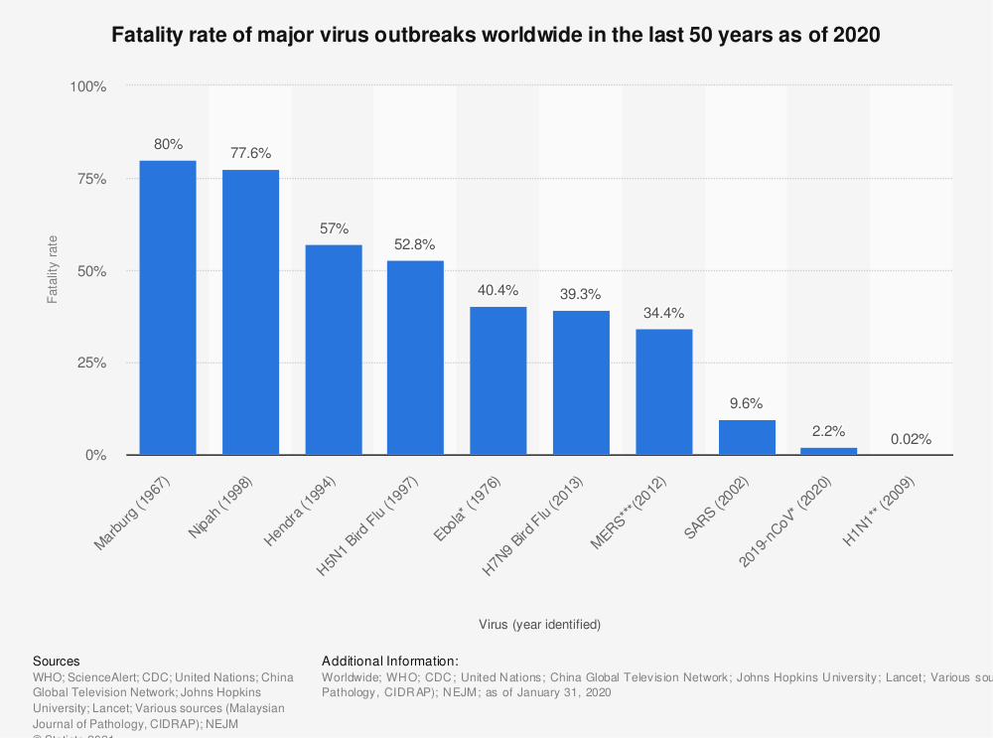

Figure 1, The fatality rate of major virus outbreaks worldwide in the last 50 years as of January 2020, [2].

And as modern society keeps growing in population with increasing migration of people from rural areas to more dense cities, it is important to investigate the efficiency of mass vaccination programs in case of any sudden disease outbreaks as a part of a preparation plan to fight against future infectious diseases.

# 2. The Problem and Goals

Mass Vaccination is often rolled out in multiple vaccination centers in big cities, where city citizens visit these vaccination centers to receive a dose of the vaccine. However, this is not necessarily the right and most efficient approach to practice mass vaccination. **We hereby propose a problem to investigate the difference between traditional centralized vaccination versus mobile vaccination where health personal visit city citizens at their homes or working places to provide them with the vaccine.**

The diagram in figure 2 below shows a summarized workflow of the traditional centralized vaccination program on the left side and a different workflow approach in mobile vaccination programs.

Figure 2, A POSSIBLE WORKFLOW OF A CENTRALIZED VACCINATION PROGRAM (LEFT), AND ANOTHER POSSIBLE WORKFLOW OF A MOBILE VACCINATION PROGRAM.

**We aim to use the powerful simulation of GPenSIM** capabilities to establish proof of which vaccination program is the more efficient in terms of speed and health protection and also help reveal the hidden strength and weaknesses of each vaccination program.

Later in the project, we will consider dividing the population into different age groups to be used as a priority between citizens to receive the vaccine. In addition, we will address the resource requirements and limitations in the number of available trained health personal who can handle the vaccines, and the availability of the required vaccines, among many other resources involved in this problem.

For simplicity reasons and to avoid any high running time of the simulation, we will be focusing on a medium-size city which is the municipality of Stavanger, where data about residents is highly trusted to be accurate and abstracted which increases the integrity of this research.

The municipality of Stavanger has an area of about 241 km2 and about 141 000 inhabitants spread over the mainland Stavanger and 37 islands, making it useful for testing and simulation considering the unique spread of people across many distant and close areas within the same municipality. For more details about the different age groups and populations of Stavanger, please look at the resources [3], [4], and [5] in the reference list.

# References

[1] The College of Physicians of Philadelphia, History of Vaccines, an educational resource by the college of physicians of Philadelphia, 2021. Available: https://www.historyofvaccines.org/timeline/all. Accessed on: 06.10.2021.

[2] Statista, Fatality rate of major virus outbreaks worldwide in the last 50 years as of 2020, 2021. Available: https://www.statista.com/statistics/1095129/worldwide-fatality-rate-of-major-virus-outbreaks-in-the-last-50-years/. Accessed on: 06.10.2021.

[3] Stavanger municipality, Fakta om Stavanger, 2021. Available: https://www.stavanger.kommune.no/om-stavanger-kommune/fakta-om-stavanger/#geografi. Accessed on: 06.10.2021.

[4] Statistics Norway, 2021. Available: https://www.ssb.no/kommunefakta/stavanger. Accessed on: 06.10.2021.

[5] Statistics Norway, Housing conditions, register-based, 2021. Available: https://www.ssb.no/en/bygg-bolig-og-eiendom/bolig-og-boforhold/statistikk/boforhold-registerbasert. Accessed on: 06.10.2021.